1. 10x10 , 1000 movies, κ=20  
   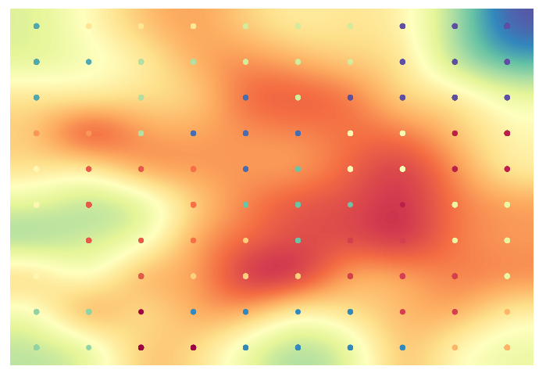
2. 10x10, 3000 movies , κ=20  
   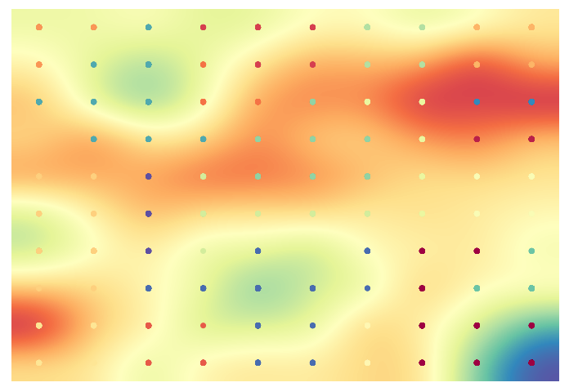

1. 20x20, 5000 movies, k=20

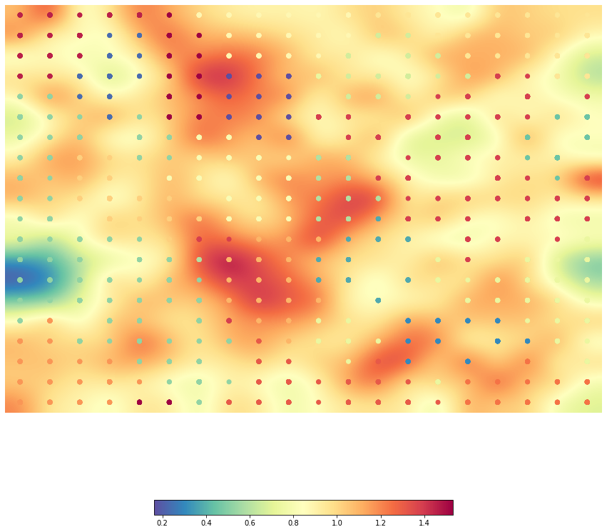

1. 20x20, 5000 movies, k=25

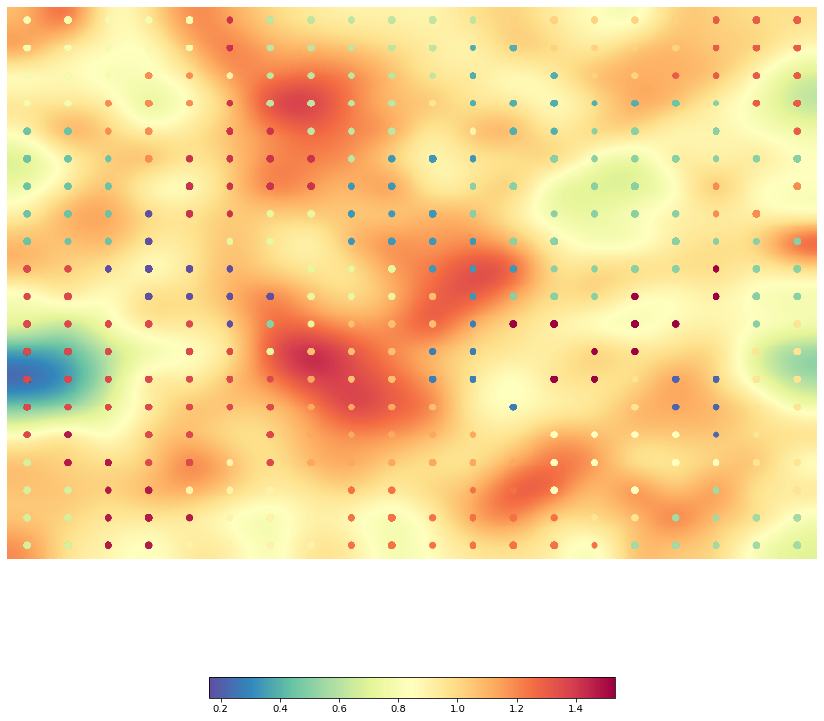

1. 25x25, 5000 movies , k=20  
   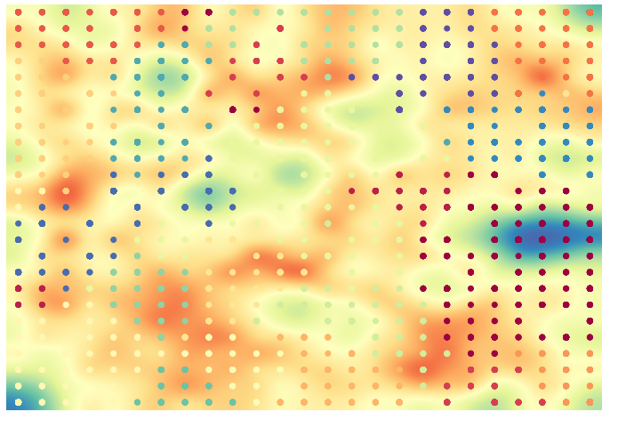
2. 25x25, 5000 movies, k=25  
   